AD LIFECYCLE ARTIFACT | External Design Document – V4.3  Detail Component Design
Application: OMS Product Model – KBS design for the Market Tracking product (new nested model) | Project Name: Order Management System
Module/Component/Executable:  Selectica Knowledgebase | Project Initiation Code: OMS
Author: Raghu K | Project Code:
Language: Java/Selectica Modeling | Time Tracking Code:
The Internal Design describes the new module or modifications to an existing module to meet the desired functional changes as specified in the External Design. The document should reference all aspects of the module being modified including detailed references to inputs and outputs. The document should also include test-planning guidelines to support Unit Testing.
1 VERSION HISTORY 2
2 OVERVIEW 2
2.1 Summary 2
2.2 Out of Scope 2
2.3 Architecture Overview: 3
3 REQUIREMENTS TRACEABILITY MATRIX 4
4 FUNCTIONAL & LOGICAL SPECIFICATIONS 5
5 DESIGN ASSUMPTIONS 5
6 DESIGN RISKS 6
7 ARCHITECTURE IMPLICATIONS 6
8 DATABASE MODEL 6
9 QUALITY CONTROL 6
10 INTERNAL DESIGN SIGNOFF (AD Only) 6
11 APPENDIXES 7

VERSION HISTORY

Version | Description of Changes | Date | Author
1.0 | Initial release | 11/20/05 | Raghu Kakanavaram

OVERVIEW

Summary

This document describes the design of the Market Tracking (MT) product offering in terms of the Selectica Knowledgebase (KBS) representation of the MT product in OMS.

The MT KBS forms the basis on which a client order for visualization/AS Model is placed using OMS.

Out of Scope

- Design of screen layout and configuration flow of the MT product model in OMS is outside the scope of this document.
- Details of the configuration constraints and model behavior including error messages are not in scope of the current document.
- The MT KBS is designed to facilitate the visualization/AS Model order for the MT product offering via OMS. There are other types of orders (such as order for data-mart creation, order for Flash reports etc.,) that this KBS may be able to facilitate via extensions. However, since this can be determined only when detailed requirements for the other order types become available, facilitating other order types in OMS using the MT KBS is out of current scope.

Architecture Overview:
The KBS design is depicted below:
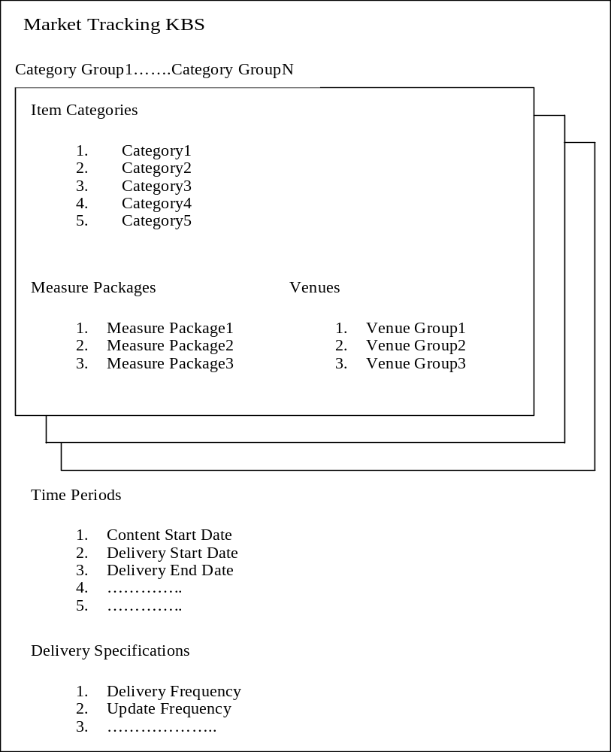

REQUIREMENTS TRACEABILITY MATRIX

E.D. # | External Design Functional Change | I.D. # | Internal Design Functional Change

FUNCTIONAL & LOGICAL SPECIFICATIONS

The Market Tracking product is the new IRI offering targeted to be implemented in the Market Knowledge infrastructure in the Release 1 timeframe.

The Market Tracking KBS is made up of the following parameters. This list is partial and more parameters will be created to model additional configuration behavior as needed:

S No. | Model | Parameter Name | Parameter Type | Comments
1 | MarketTracking | CategoryGroup | Nested Model | The container nested model created to group item categories with measures and venue group selections.
2 | MarketTracking | NumberOfGroups | Numeric | The number of dynamic containers needed to be created during order time.
3 | CategoryGroup | ItemCategory | Multi-value Enumerated | The set of selectable categories offered (subject to constraints)
4 | CategoryGroup | MeasurePackage | Multi-value Enumerated | The set of measure packages offered (subject to constraints)
5 | CategoryGroup | Venue Group | Multi-value Enumerated | The set of venue groups offered (subject to constraints)
6 | MarketTracking | Content_Start_Date | Date
7 | MarketTracking | Delivery_Start_Date | Date
8 | MarketTracking | Delivery_End_Date | Date
9 | MarketTracking | Delivery_Frequency | Single-value Enumerated
10 | MarketTracking | Update_Frequency | Single-value Enumerated

DESIGN ASSUMPTIONS

- All the seed data (dimensional data) for the MT product model is assumed to be provided as following:
  - Item Categories – Dimension Management System
  - Alternative Item Hierarchy Levels – Dimension Management System
  - Venue Groups – Dimension Management System
  - A-la-carte Measures – Measure Authoring Tool
  - Measure Packages – TBD
  - Time Periods – Dimension Management System
  - Client Information – TBD

- The current design of the MT product model is based on the preliminary requirements made available to the OMS team. Any significant change or additions observed in the final requirements may lead to refactoring of the current design.

DESIGN RISKS

- The end-to-end architecture for the visualization/AS Model order flow through OMS is not yet finalized. Depending upon the downstream objects that need to be facilitated, the design of the primary MT order object as well as the MT KBS is subject to change.
- A more generic KBS design may need to be created to accommodate the other order types (MT data-mart orders, Flash report orders, DIV orders etc.,). This may lead to some refactoring of the MT KBS or creation of new, separate KBS’.

ARCHITECTURE IMPLICATIONS

-N/A-

DATABASE MODEL

-NA-

QUALITY CONTROL

INTERNAL DESIGN SIGNOFF (AD Only)

Signoff - Name | Functional Area | Signoff Date

APPENDIXES

